Claveria, Jorlyn Shane M.
Reyes, Maria Theresa N.
Segotier, Joy Melisa S.
Estolloso, Marc Christian
BS INFO 3C – INFOE 4 – LAB 3


Screenshot of systemctl status openvpn-server@server showing "Active (running)".

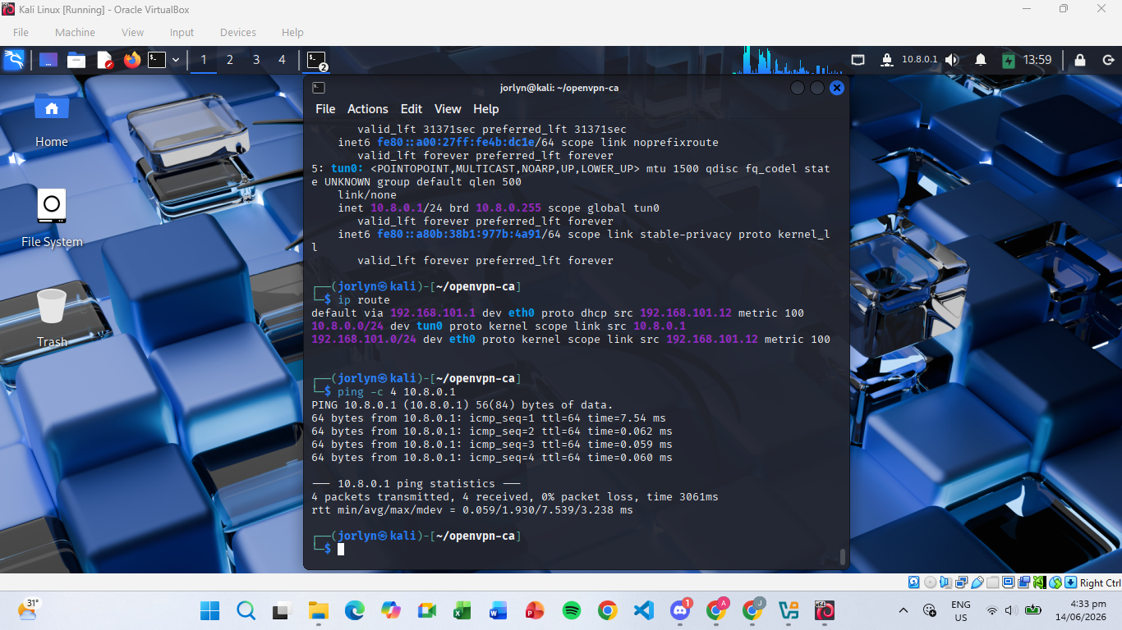
Screenshot of a successful ping 192.168.1.100 from the remote client.

Critical Thinking & Performance Analysis
1. UDP vs. TCP: Why is UDP preferred for VPNs? (Hint: Research "TCP Meltdown" or "TCP over TCP").
UDP is preferred for VPNs because it is faster and more efficient than TCP. It sends data without waiting for confirmations, which reduces delays and improves performance. This makes VPN connections faster and more responsive, especially for activities like browsing, streaming, and file transfers.
2. PKI Security: If an employee leaves the company, we have their certificate, but they still have a copy on their laptop. How does a Certificate Revocation List (CRL) solve this?
A Certificate Revocation List (CRL) is a list of certificates that are no longer valid. If an employee leaves the company, their certificate is added to the CRL. When they try to connect to the VPN, the server checks the CRL and blocks access if their certificate has been revoked.
3. Visibility: When the client pings 192.168.1.100, does the research server see the client's real IP or the VPN IP (10.8.0.6)? Why?
When a client connects to the VPN, it receives a VPN IP address from the VPN network, such as 10.8.0.6. All traffic sent through the VPN uses this VPN IP address. As a result, the research server sees the client's VPN IP instead of the client's real public IP address, making communication secure and private.

